GRANT RECIPIENT MEDIA KIT
Your program is important and worthy of media attention. Publicity and media coverage will help ensure the success of the funded project, your organization and Kenai Mountains-Turnagain Arm National Heritage Area. To help you communicate the impact of your work, we have provided a Grant Recipient Media Kit.
KMTA is always interested in capturing the stories of our grantees. Telling your story helps to tell our story! Compelling storytelling helps communicate to our donors and the greater community the importance of supporting projects like yours. We often feature stories of our grantees in our marketing materials, including our newsletters and annual reports. If you have a story that you would like to share, please contact Karen Lewis, Communications and Marketing Manager.
The following materials are intended for the use of KMTA grantees and will help you get the recognition your project and organization deserve. Here are some suggested ways to announce your project’s grant award:

RECOGNITION
Please acknowledge the KMTA’s support with our name and logo in publications, programs and signage for any event or presentation funded that received grant funding.
Please always use our full name—Kenai Mountains-Turnagain Arm National Heritage Area (KMTA)—when referencing us initially then KMTA after. Where possible, please include the written acknowledgement below as well as the logo:

This grant was made possible by:
Kenai Mountains-Turnagain Arm National Heritage Area.
-Or-
This project was funded (or funded in part) by a grant from:
Kenai Mountains-Turnagain Arm National Heritage Area.

LOGO USE
- There are two logo versions in both color and black & white available. Please contact Karen Lewis for the correct logo file that will suit your needs.

- Place the logo upright and do not alter it in any way. Acceptable use of the KMTA’s logo includes, but is not limited to: newspaper ads, TV ads; newsletters, postcards, brochures; websites and social media channels. We encourage you to use the KMTA Logo where suitable.
Option 1 for a light background:
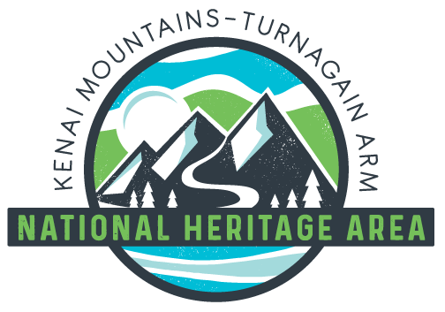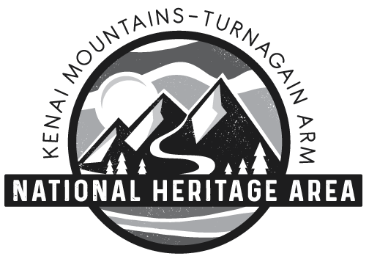
Option 1 for a dark background (Some text is not showing due to the white background.):
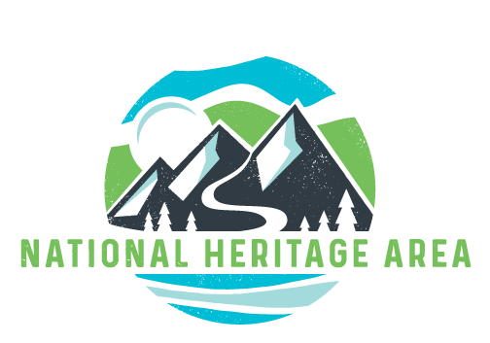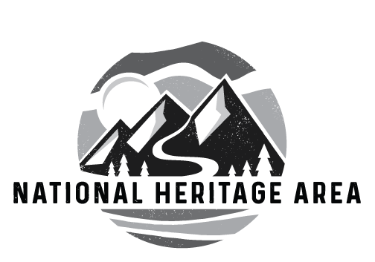
Option 2 for a light background:
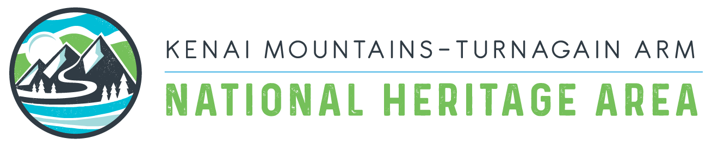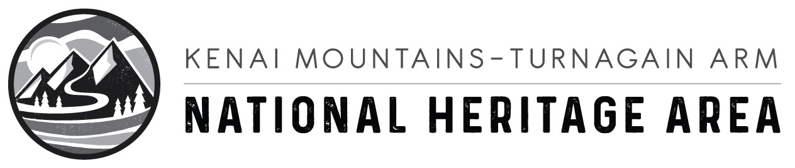
Option 2 for a dark background (Some text is not showing due to the white background.):
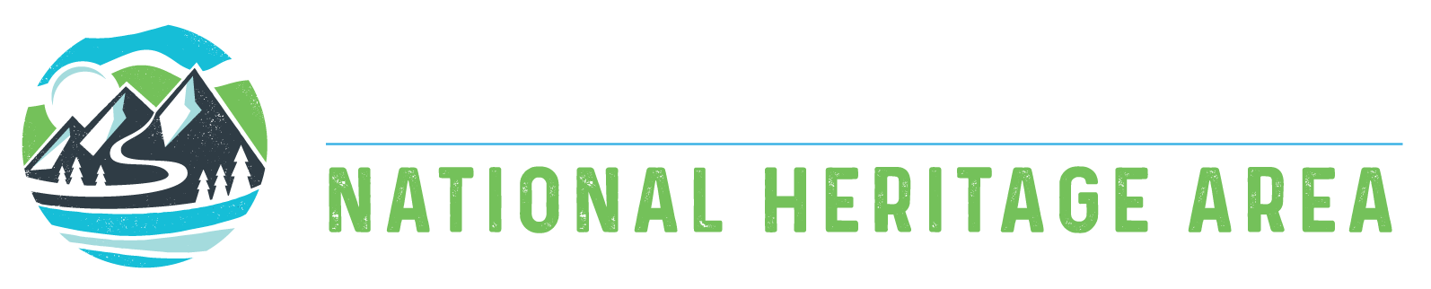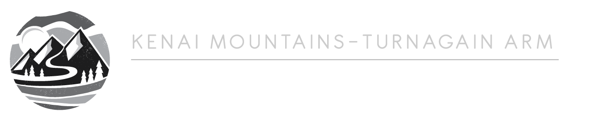

PRESS RELEASE
- Issue a press release announcing the grant award, always try to include pictures of the program, along with the KMTA Logo and the logo of your organization.
- Utilize the Sample Press Release as a guideline. We are happy to provide a quote for your press release. Please email us to request a quote from a KMTA representative. Consider hosting events to mark your project’s major milestones. Include donors, elected officials and community leaders in photo opportunities. Invite media to cover the event and distribute a pre- and post-event press release with the newsworthy highlights, as appropriate.

OFFLINE & ONLINE PUBLICATIONS
- Feature the grant award in newsletters, eblasts, social media, donor update letters and on your website. Include a compelling photo of the project or the residents you are serving, the check presentation, etc.
- Utilize the Sample Newsletter Article as a guideline.

INFORM YOUR BOARD OF DIRECTORS/GOVERNMENT REPRESENTATIVES
- Please notify your board about your recent grant from the Kenai Mountains-Turnagain Arm National Heritage Area.
- Letters from community organizations help legislators understand the importance of investing public funds in your community.
- Utilize the Sample Letter to help you get started.

SOCIAL MEDIA
- Facebook (www.facebook.com/KMTANationalHeritageArea)
  - Like KMTA’s page and we’ll like your page
  - Mention @KMTANationalHeritageArea in grant related posts, photos and events
- Instagram (www.instagram.com/kmta_corridor)
  - Follow KMTA and we’ll follow you
  - Mention @kmta_corridor in grant related posts and photos

Facebook and Instagram Sample Posts
- Share these on your favorite social media channel, and don't forget to download our social images to go with your post!

Post 1
- We would like to thank the Kenai Mountains-Turnagain Arm National Heritage Area (KMTA) @kmta_corridor (Instagram) @KMTANationalHeritageArea (Facebook) for recognizing the work we do for the people in the KMTA area and supporting our mission by providing us with a grant of [amount of grant]. We will use this money to [Explain what the grant will be used for].

Post 2
- We would like to express our gratitude to the Kenai Mountains-Turnagain Arm National Heritage Area (KMTA) @kmta_corridor (Instagram) @KMTANationalHeritageArea (Facebook) for showing their support in our mission of helping South Carolinians receive access to [purpose of grant] by giving us a grant of [amount of grant]. This financial contribution will be used to further the work we do and help Alaskans’ succeed in [purpose].

Post 3
- We’re excited to announce that we have just received a grant of [amount of grant] from the Kenai Mountains-Turnagain Arm National Heritage Area (KMTA) @kmta_corridor (Instagram) @KMTANationalHeritageArea (Facebook) It is an honor to be recognized for the work we are doing to [purpose of the grant], and it is an honor to receive this support to be able to continue doing just that. We plan to use this money to [specifics about spending]. Find out more about KMTA, how they work with the people of the heritage area, and the organizations they support by clicking the link below.
- www.kmtacorridor.org

Post 4
- Together with the Kenai Mountains-Turnagain Arm National Heritage Area (KMTA) @kmta_corridor (Instagram) @KMTANationalHeritageArea (Facebook), we are dedicated to strengthening the heritage area through supporting community projects. Today, we are happy to share that we have received [amount of grant] grant from the KMTA. This money will go towards [specifics about spending]. Thanks, Kenai Mountains-Turnagain Arm National Heritage Area! Click the link below to find out more about the KMTA, their partnership with local community groups, and the work they are doing for the communities on the Eastern Kenai Peninsula.
SOCIAL MEDIA POST IMAGES (These are sample post images - we can do something different entirely):
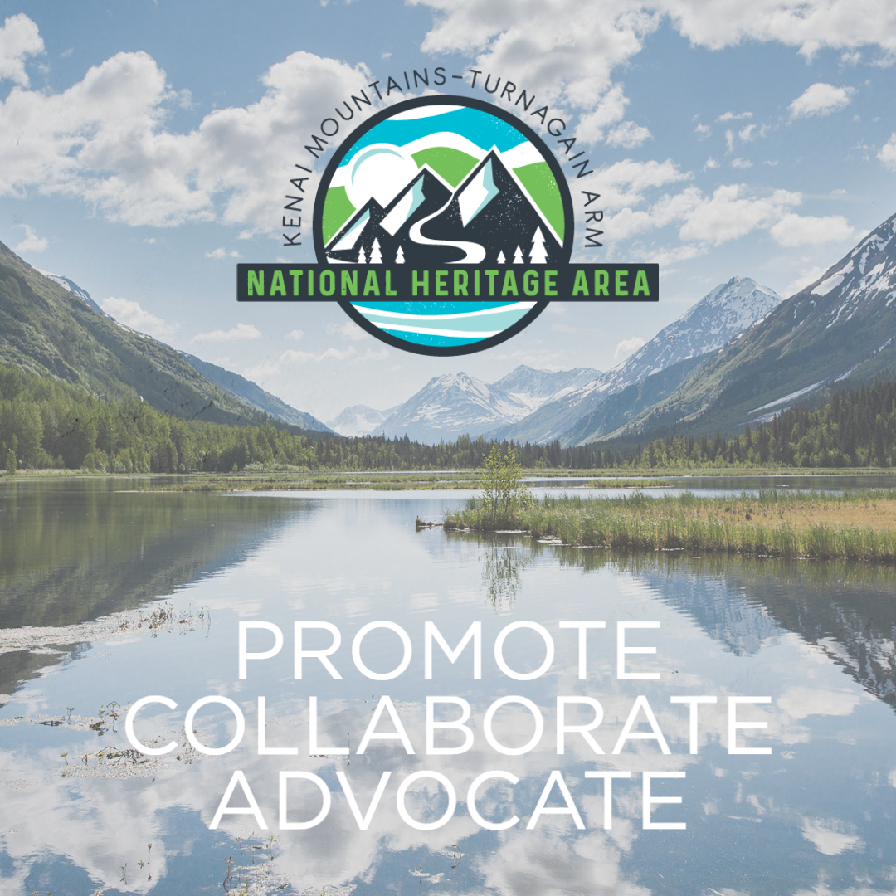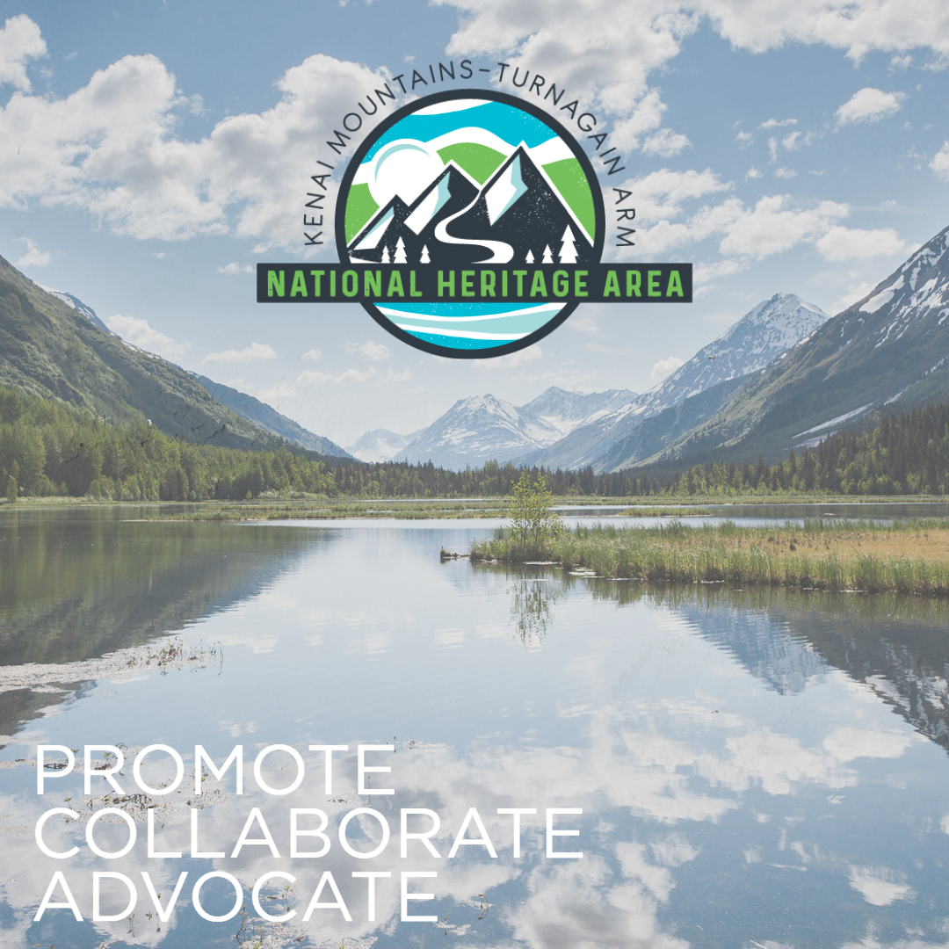

OUR NAME AND ORGANIZATIONAL DESCRIPTION
- Please use “Kenai Mountains-Turnagain Arm National Heritage Area” when referring to the organization. When including a description, please use the following:

Kenai Mountains-Turnagain Arm National Heritage Area awards grants to community projects that recognize, preserve, and interpret the historic, scenic, and natural recreational resources and cultural landscapes of the Kenai Mountains-Turnagain Arm historic transportation corridor. Projects promote and facilitate public enjoyment of these resources. KMTA seeks to equitably fund diverse activities geographically distributed throughout the communities and transportation corridor of the Heritage Area.

SHARE YOUR STORY
- We would like to hear how a grant from KMTA has helped your organization. If you would like to share your story of impact from a grant, please send a narrative, photo or video to us. KMTA highlights its grantees through the media, on our website and in our Report to the Community

PHOTO OPPORTUNITIES
- Take advantage of opportunities to capture and share appealing images. KMTA features grant recipients in our printed publications, on our website and on our Facebook Page & Instagram. Please share your images with us. With advance notice, we can often arrange to attend events or visit programs.

SENDING PHOTOS TO KMTA
We are actively building a collection of grantee photos (high-resolution, digital images) and ask that you send us photos that may be used to help promote or spotlight the project for which you received a grant. We prefer photos of candid moments or action shots of grant-related activities in high resolution (at least 300 dpi) JPGs.

Prior to sending us your photos, please ensure you have written consent from individuals in the photos. We will archive your photos on file for use on KMTA’s website, presentations, and other online or printed materials. We will be sure to credit your organization each time we use your photos.

YOUR LOGO HERE

N E W S R E L E A S E

FOR IMMEDIATE RELEASE
Date
Contact:
Contact Person Name, Title, Organization
Phone Number
Website

HEADLINE
Your City Here, AK – DATE –Begin your press release with a two sentence paragraph that provides a quick overview of the news and why it is important. It should read easily and make your news sound exciting to a general audience.
Next, provide some background information on your organization, program or project. Make sure to write your release in terms that the general public will understand.
Next, you can include a quote from your organization’s Executive Director or Board member.

Kenai Mountains-Turnagain Arm National Heritage Area, also, is happy to provide a quote about your organization. Please contact us for a quote.
The final two paragraphs should include boiler plate information about your organization and its history, as well as the below information about KMTA:

About Kenai Mountains-Turnagain Arm National Heritage Area
KMTA awards grants to community projects that recognize, preserve, and interpret the historic, scenic, and natural recreational resources and cultural landscapes of the Kenai Mountains-Turnagain Arm historic transportation corridor. Projects promote and facilitate public enjoyment of these resources. KMTA seeks to equitably fund diverse activities geographically distributed throughout the communities and transportation corridor of the Heritage Area. KMTA has invested more than 1.2 million in grants with over $$$$ in matches provided through in-kind and volunteer donations over its 13 year history. To learn more, visit kmtacorridor.org.

Lastly, repeat "For more information, contact:" as the last sentence.
### (These marks are centered just below the content of the release and signal the end of the release.)

Sample Letter
It's best to keep letters to state and federal agencies to one page. Give specific details about your organization and projects. Send copies of news clippings and promotional materials you feel will help the recipient better understand your work with the Foundation.
Date
Title and Name of Official
Address
Dear Title and Last Name:
We are pleased to report that we have received a $XXX grant from the Kenai Mountains-Turnagain Arm National Heritage Area. These funds will allow us to (Describe your grant project. Include who it will serve, the benefits to the community and to the region, the major milestones, etc.)
Optional: In addition to KMTA, we also have received financial support from other contributors, including X, Y and Z.
We invite you to attend our upcoming (event/exhibit/open house/class/etc.). We would be honored to have you personally see how philanthropic support and grant making makes a difference in our organization. (Invitations are enclosed; the event will take place on, etc.) In the meantime, I'd like to share our latest newsletter and press releases on our project. (If possible, include this information with letter)

Sincerely,
Your Name
Title, Organization

Sample Newsletter Article
Meet our partner...Kenai Mountains-Turnagain Arm National Heritage Area
Have you heard that (organization name) has received a $XXX grant from the Kenai Mountains-Turnagain Arm National Heritage Area (KMTA) this year? These funds will be used to support our XXX project and will directly help us to (insert details; include who the project will serve, the overall goal and how it relates to your mission).
(Insert short quote from your president, executive director or board chair about the impact this grant will have on the organization and its project. Use the opportunity to ask constituents for additional support, if needed.)
KMTA awards grants to community projects that recognize, preserve, and interpret the historic, scenic, and natural recreational resources and cultural landscapes of the Kenai Mountains-Turnagain Arm historic transportation corridor. Projects promote and facilitate public enjoyment of these resources. KMTA seeks to equitably fund diverse activities geographically distributed throughout the communities and transportation corridor of the Heritage Area. KMTA has invested more than 1.2 million in grants with over $$$$ in matches provided through in-kind and volunteer donations over its 13 year history.

