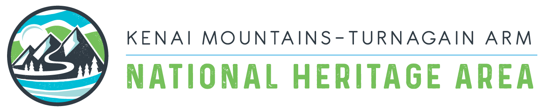

KMTA Reimbursement Request
Project Narrative
2022

Date of Request:
Name of Person Making Request:
Email Address:

Name of Sponsoring Organization:

Mailing Address (include city & zip code):

Phone Number:

Name of Grant Project or Program:

Date of Award:

Reimbursement Request Amount $:

Make Check Payable To:

Match Amount $:

Description of Project and Status (i.e. is the project complete? If not, what remains?) Please note any changes in your project that might vary from the original project proposal. (1-2 paragraphs)

Please answer the following questions:
1. How did your project increase public awareness and appreciation for the natural, historic, scenic, and cultural resources of the KMTA National Heritage Area?

2. How many people participated in your project?

3. Who were your formal project partners and how were they involved?
Who were your informal project partners and how were they involved?

4. How was KMTA recognized in the project?

5. Did you accomplish project objectives & activities? Please specify how you measured your success and how each project objective was met. (i.e. # miles of trail maintained; # of historic documents/ items preserved; # of historic buildings preserved; # of people reached/ participants)

6. How will this project benefit KMTA Heritage Area and people who visit or live in the corridor into the future? How will the project results be maintained to ensure longevity?

7. Please include photographs and videos if available. Unless specifically prohibited by the grantee KMTA CCA may include this information and photos in press releases, newsletters, social media, and promotional material.

8. Please also include a quick synopsis of the overall success of your project in your own voice/words for your community/organization that can be utilized in KMTA’s newsletter and shared. (Suggested format: 4-6 sentences explain project goals, work completed, volunteers involved, historical/cultural/scenic/natural significance, and final outcomes). If your project contributed to the local economy, please describe jobs created, investment made, or in-kind contributions provided.

9. Any Additional Information to share about your project (Ie. Challenges, unanticipated successes, interesting or notable circumstances).

When complete, email to jessawest@kmtacorridor.org accompanied with Expense report and proper documentation (this should include all volunteer logs and ALL receipts for items that you are seeking to be reimbursed for)

If you have any questions, please contact Jessa West at jessawest@kmtacorridor.org (Development Manager), or Rachel Blakeslee at rachelblakeslee@kmtacorridor.org (Executive Director).
Thank you for your good work and congratulations on completing your project!

** Please note that KMTA reimburses on a monthly payment schedule. Reimbursement requests approved by the first Thursday of each month will be sent funds by the second Thursday of the same month.

