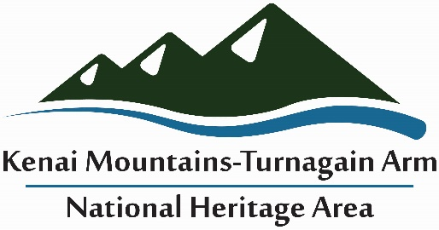
Community Training Scholarship Application
Community Training Scholarships are available for up to $350 each as a mini-grant from the Kenai Mountains-Turnagain Arm National Heritage Area. Scholarship funds are designated for continuing education and training opportunities for community members within the Heritage Area. To apply for a training scholarship, please complete the following form and include a letter of interest. Scholarship funds are reimbursable upon submission of:
- Conference registration receipt; Agenda; Course description;
- Travel costs as match: Per diem rates & mileage calculations (if applicable)
- Total volunteer hours recorded as In-Kind Match (include travel to/from conference, time at conference, and time spent reporting back to the organization you represent)
- A paragraph description of what you learned and how it applies to your community
Today’s Date: _______________ Date(s) of Training: ___________________
Name of Scholarship Applicant: _______________________________________________________
Point of Contact (if different than applicant): _____________________________________________
Recipient Contact phone: ______________________ Email: ______________________________
Name of Organization: _________________________________Phone: _______________________
Address: __________________________________________________________________________
Community within KMTA Heritage Area that will benefit: ___________________________________
Letter of Interest that addresses 1) the purpose of the training, 2) why it is important, 3) who will benefit, and 4) relevance to the KMTA Heritage Area purpose to recognize, preserve, interpret, and promote the historic, scenic, and natural recreational resources and cultural landscapes of the KMTA historic transportation corridor.

Amount requested: $_________ (up to $350)
This mini-grant requires equal or more non-federal matching funds. This can be all or part in-kind such as conference time, administrative time, advance preparation, etc. Please list the amount of non-federal match the applicant and/ or associated organization can provide. (Must be equal to or greater than the amount requested.)
Value of match: ___ applicant paid hours (non-federal) @ $______/hr = $ _______
___ volunteer hours @ $27.45/hr = $ _______
Other in-kind:
TOTAL MATCH _______________
Email to: katherineschake@kmtacorridor.org
For more information call Katherine Schake (907) 205-0235.

